Stary Mlyn
On our second day in Terchova we hiked the Janosikove Diery in the national park Mala Fatra where legend has it that Slovakia’s most enduring hero Juraj Janosik avoided the drabi (hence the name, Janosik’s Gorge).
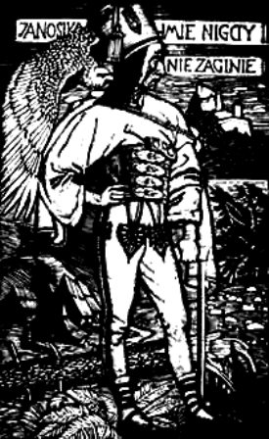
The trail began with open fields full of wild flowers and the amazingly stereophonic periodic drone of insects that always accompanies any trail cut through meadows of high grass.
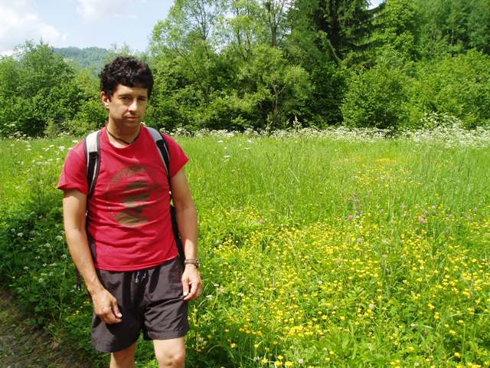
Off to the left of the field there was a modest brook, but it wasn’t long before the fields gave way to crystal-clear waters that would soon cut through deep rock gorges .
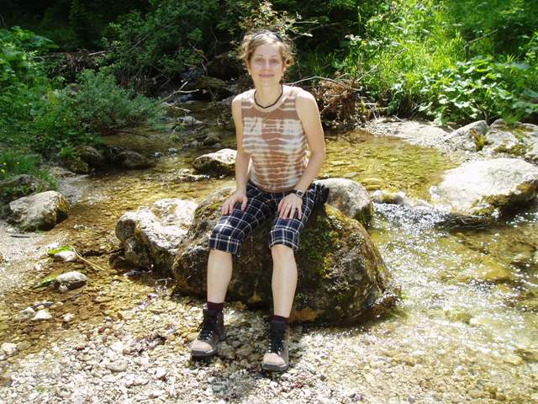
All the Slovak trails I hiked were well kept and clearly marked, and most offered multiple routes to a common destination. At Janosikove Diery we choose the narrow waterway passage between Velky Rozsutec and Maly Rozsutec to go in
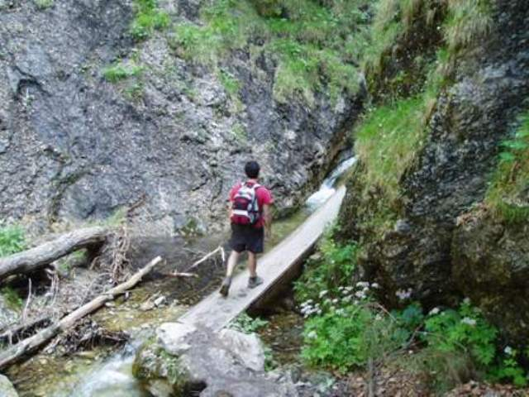
and took the more forested trails that ran alongside and above the river gorges on the way out.
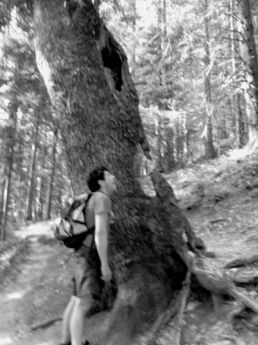
The trail along the gorge is either cut directly into the rock walls
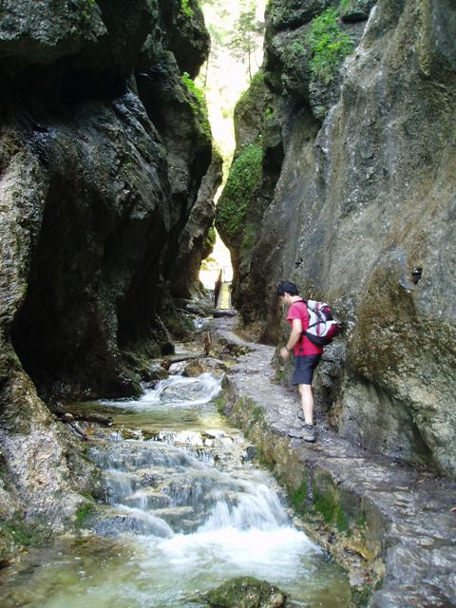
or linked together by way of ladders,
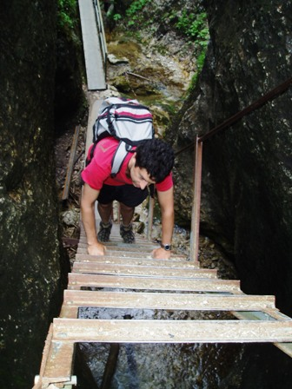
footbridges
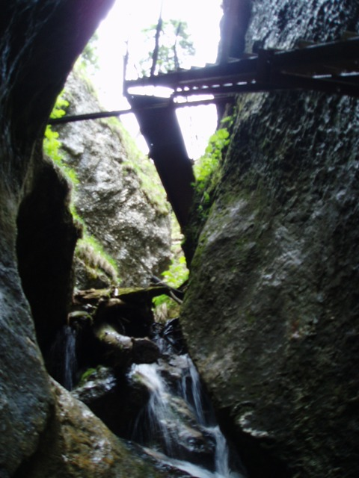
and chains and railings.
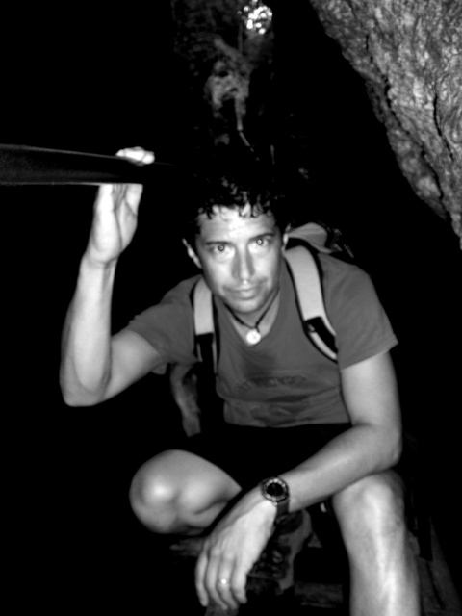
While everything is made just safe enough, you do have to be careful as everything is wet and several ladders and bridges are perched over unforgiving chasms.
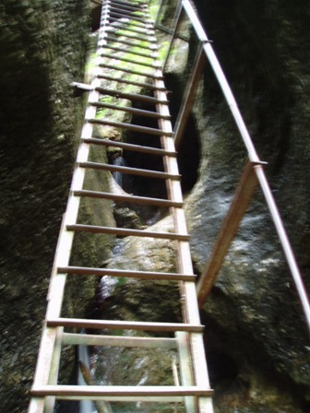
Eventually the deep crags and waterfalls opened up again to a stunningly beautiful and dreamlike alpine meadow
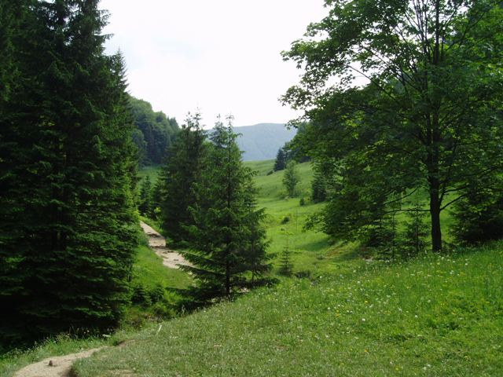
I think it’s fair to say that in our dreams there exists a vast choir of feedback and reverberations thrown off like shadows from the things we do and think. This seems clear to me and would comfortably account for most of my dreaming—albeit with a healthy dose of subconscious surrealism, smudge and noise! However, I’ve also dreamt a few persistent images and ideas that seem to turn this logic upside-down and hint at a world where life itself is the distant echo and dreaming the strike at the heart of it.
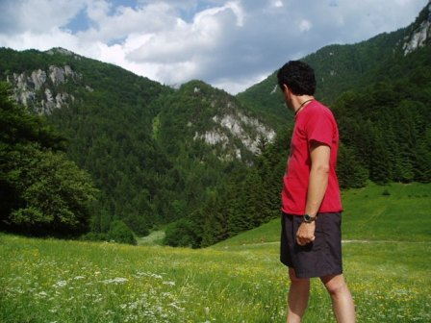
I dreamed this very field last summer, and in the dream I was waking with Lubka.
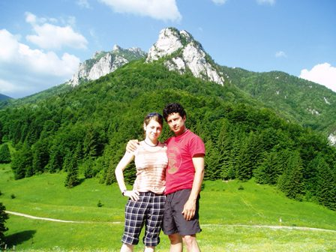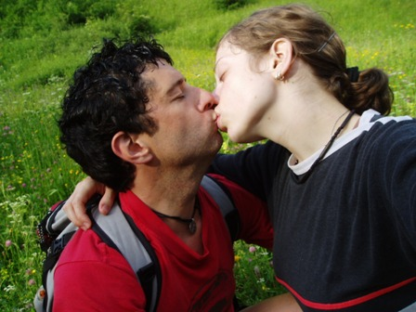
Physically walking into it was like experiencing the warm glow of a favorite memory in real-time .
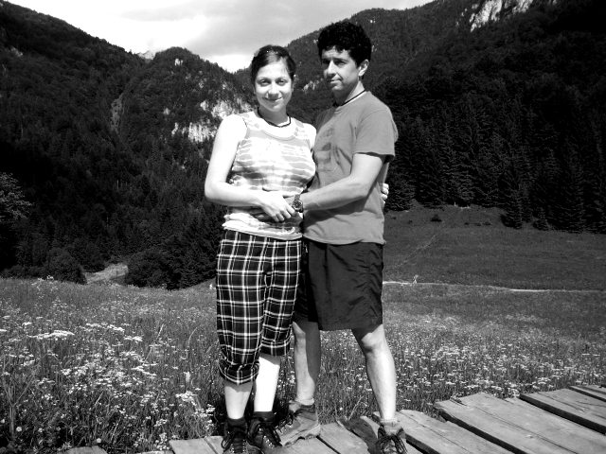
*The strangers are carrying the seeds
They're coming from faraway places
They don't stop at the gates
They're coming through them closed
As though through walls of smoke
In the evening fires
(Iva Bittova *

